Software Requirement Specifications
Crypto Gateway: Revolutionizing Digital Payments


Submitted by
Momna Nasir F22BINFT1M01027
Bushra Nadeem F22BINFT1M01045
Submitted to
Dr. Dost Muhammad Khan

Department of Information Technology
Faculty of Computing
The Islamia University of Bahawalpur

Meeting Details
Sr No | Details | Date | Supervisor Signature
1 | Discussed the basics of SRS | 18 November
2 | Brief Explaination of Project | 24 November
3 | Conversation on functional requirements | 30 November
4 | Discussing The SRS | 3 December

Summary
Here the author will write summery of the document. They can provide a brief of the background, their findings and requirements.

This document presents the software requirements for Crypto Gateway, a modern cryptocurrency payment gateway designed to empower online merchants with secure, efficient, and decentralized payment processing. The system addresses the growing need for alternative payment methods in e-commerce by enabling businesses to accept Bitcoin (BTC), Ethereum (ETH), and Solana (SOL) directly on their websites. Key findings from market analysis reveal that existing solutions are either centralized, costly, or lack seamless integration. Crypto Payment Gateway introduces a self-hosted, API-driven gateway with real-time transaction verification, merchant dashboards, and automated refund processing. The system is built using the MERN stack and open blockchain libraries, ensuring scalability, security, and ease of deployment.

Table of Contents
1. Introduction 4
1.1. Purpose 4
1.2. Scope 4
1.3. Product Perspective 4
1.4. User Characteristics 4
1.5. Similar apps and systems/Literature Review 4
1.6. Proposed Technologies 4
2. Requirements 5
2.1. Function Requirements 5
2.1.1. Sign Up 5
2.2. Non-Functional Requirements 5
3. Use Cases and Flow of Processes 6
3.1. Use Case 1 7
4. References 8

- Introduction
Purpose
CryptoGate is a standalone payment gateway module that integrates with e-commerce platforms such as WooCommerce, Shopify, and custom websites. It enables merchants to generate payment links and embedded checkout buttons for customers to pay using cryptocurrencies. The system operates independently of centralized payment processors, giving merchants full control over funds while maintaining transparency through blockchain verification. This project focuses exclusively on the payment processing and merchant management module, laying the foundation for future extensions like invoice systems and analytics.

Scope

The primary goal of FreeCryptoGate is to provide a reliable, secure, and easy-to-integrate cryptocurrency payment solution that reduces transaction costs and eliminates intermediaries. Objectives include enabling real-time payment confirmation, supporting multiple blockchains, offering a user-friendly merchant dashboard, and ensuring compliance with basic KYC/AML practices through optional verification flows.
  - Product Perspective

The system will include user registration for merchants, API generation for website integration, real-time payment processing with blockchain confirmation, transaction history tracking, and refund initiation via smart contracts. It will support BTC, ETH, and SOL with dynamic wallet address generation and management. Excluded features include fiat withdrawal automation, advanced tax reporting, physical POS terminals, and full cryptocurrency exchange functionality. The scope is limited to web-based interfaces and RESTful APIs.
  - User Characteristics
- Merchants: Business owners or developers integrating the gateway into online stores. They require basic technical knowledge to install plugins or use APIs.
- Customers: End-users paying with crypto wallets (e.g., MetaMask, Phantom). No account needed; interaction is one-time per transaction.
- Administrators: System maintainers who monitor performance, update node connections, and manage merchant approvals.
  - Similar apps and systems/Literature Review

BTCPay Server is a leading open-source solution offering full Bitcoin payment processing with invoice management and direct wallet control. However, it lacks native support for Ethereum and Solana and requires server administration skills. CoinPayments supports over 100 coins but operates as a custodial service with 0.5% fees and limited customization. SpicePay provides simple integration but has been discontinued. Research papers on blockchain payment systems emphasize the need for multi-chain support and real-time confirmation without third-party reliance. Crypto Gateway improves upon these by combining BTCPay’s sovereignty with multi-chain compatibility and a modern web interface, eliminating setup complexity.

  - Proposed Technologies
The system will be developed using the MERN stack:
React.js for building a responsive and interactive frontend interface.
Node.js to handle server-side logic and real-time processing.
Express.js to manage API routes, middleware, and database connectivity.
MongoDB as the NoSQL database for storing merchant profiles, transactions, and API keys. Additional libraries include Web3.js and Ethers.js for Ethereum interactions, bitcoinjs-lib for Bitcoin address generation and validation, and @solana/web3.js for Solana transactions. CoinGecko API will be used for live price feeds.

- Requirements

Crypto Gateway allows merchants to register, generate unique API keys, and embed payment buttons or checkout pages on their websites. Customers scan QR codes or copy wallet addresses to send payments. The system monitors blockchain networks in real time, confirms transactions within expected block times, and updates merchant dashboards instantly. Merchants can view transaction history, export data, and initiate refunds using pre-deployed smart contracts.

Administrators approve new merchant accounts and monitor system health through logs and alerts.
  - Function Requirements
Authors will provide definite number of functional requirements in standard format. These requirements directly in the with functions which are already provided. The requirement format as following.
Name: FR001
- Purpose: Enable merchants to create accounts and access gateway features
- User(s): Merchants
Input:
- Full Name: As per business registration.
- Email: Valid and verifiable address.
- Password: Minimum 12 characters with symbols, numbers, and mixed case.
- Business Name: Official trade name.
- Website URL: Active domain for verification.
Output: Activated merchant account with dashboard access and API key generation option

Name: FR002
Purpose: Allow secure login with session management.
User(s): Merchants, Administrators
Input:
- Email
- Password
- 2FA Code (optional, via authenticator app)
Output: JWT token and redirect to personalized dashboard.

Name: FR003
Purpose: Generate dynamic payment requests for customers.
User(s): Merchants
Input:
- Amount (in USD or crypto)
- Currency (BTC, ETH, SOL)
- Order ID (from merchant system)
Output: Unique payment page with QR code, wallet address, and countdown timer.

Name: FR004
Purpose: Monitor and confirm incoming blockchain transactions.
User(s): System (Automated)
Input:
- Transaction Hash
- Expected Amount
- Recipient Address
Output: Confirmed status update in database and webhook notification to merchant.

Name: FR005
Purpose: Provide real-time transaction dashboard for merchants.
User(s): Merchants
Input:
Filter by date, status, or currency Output: Table view with exportable CSV and visual charts.

Name: FR006
Purpose: Initiate refund via smart contract (ETH/SOL) or manual BTC transfer.
User(s): Merchants
Input:
Transaction ID
Refund Amount
Reason Output: Refund transaction broadcasted and tracked.

  - Non-Functional Requirements
The system must achieve 99% uptime using clustered Node.js instances, respond to API requests within 800ms under normal load, and support up to 1000 concurrent merchants. Data must be encrypted at rest and in transit using HTTPS and MongoDB field-level encryption. The interface should be responsive across devices with loading times under 2 seconds. Blockchain node connections must auto-reconnect on failure, and all transaction logs retained for 12 months.

- Use Cases and Flow of Processes

Use Case 1:
Field | Description
Actors | Merchant, Administrator
Preconditions | Merchant has access to the registration page; Administrator has login privileges.
Postconditions | Merchant account is created and activated, with API key option available.
Flow of Events | 1. Merchant navigates to the registration form. 2. Merchant enters Full Name, Email, Password, Business Name, and Website URL. 3. System validates inputs (e.g., email format, password strength, website activity). 4. System submits registration for Administrator approval. 5. Administrator reviews and approves/rejects the account. 6. If approved, System sends activation email and grants dashboard access.
Alternative Flows | If validation fails, prompt Merchant to correct inputs. If rejected, notify Merchant with reason.
Exceptions | Network failure during submission—retry or error message.
Mapped to Functional Requirement | FR001

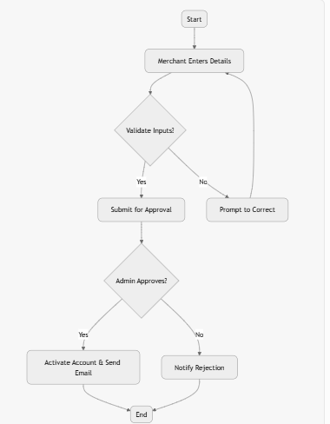

Use Case 2:
Field | Description
Actors | Merchant, Administrator
Preconditions | User has a registered account.
Postconditions | User is authenticated and redirected to dashboard.
Flow of Events | 1. User enters Email and Password on login page. 2. (Optional) User enters 2FA code if enabled. 3. System validates credentials against database. 4. System generates JWT token. 5. System redirects to personalized dashboard.
Alternative Flows | Forgot password—initiate reset flow via email.
Exceptions | Invalid credentials—display error and limit attempts to prevent brute force.
Mapped to Functional Requirement | FR002

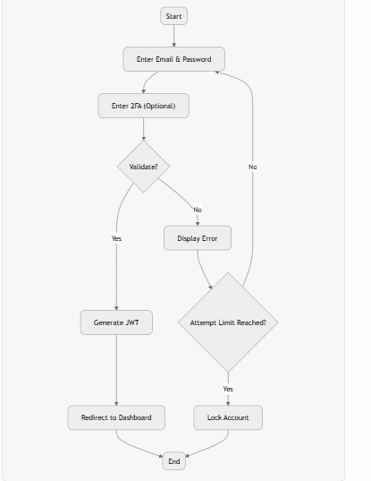

Use Case 3 :
Field | Description
Actors | Merchant, Customer
Preconditions | Merchant is logged in; Customer has a crypto wallet.
Postconditions | Payment page is generated and accessible for Customer.
Flow of Events | 1. Merchant inputs Amount, Currency (BTC, ETH, SOL), and Order ID via API or dashboard. 2. System generates dynamic wallet address and QR code using blockchain libraries. 3. System creates a unique payment page with countdown timer. 4. Merchant embeds or shares the payment link/button. 5. Customer scans QR or copies address and sends payment from wallet.
Alternative Flows | If amount in USD, convert to crypto using CoinGecko API.
Exceptions | Blockchain node unavailable—fallback to cached prices or error.
Mapped to Functional Requirement | FR003

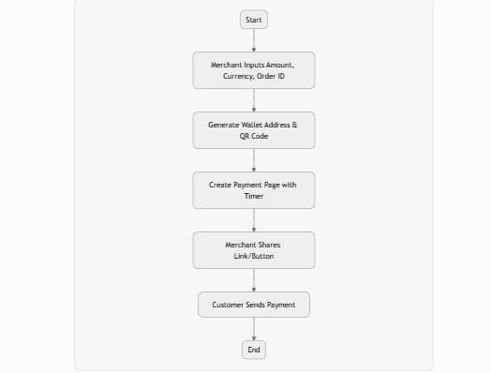

Sequence Activity :

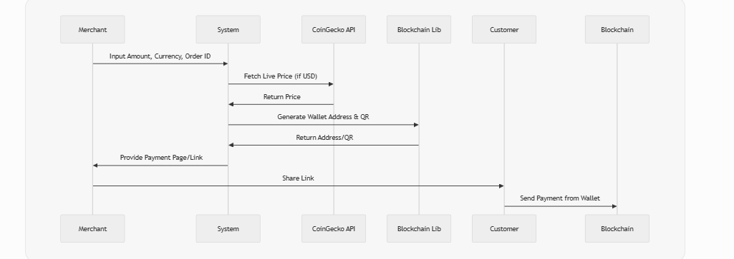

Use Case 4:
Field | Description
Actors | System (Automated)
Preconditions | Payment request exists; Transaction hash provided.
Postconditions | Transaction status updated; Merchant notified.
Flow of Events | 1. System receives transaction hash from blockchain listener. 2. System verifies hash against expected amount and recipient address. 3. System waits for required confirmations (e.g., 1 for BTC, 3 for ETH). 4. Upon confirmation, update database status to "Confirmed". 5. System sends webhook notification to Merchant.
Alternative Flows | Partial payment—flag as underpaid.
Exceptions | Timeout—mark as pending and retry polling.
Mapped to Functional Requirement | FR004

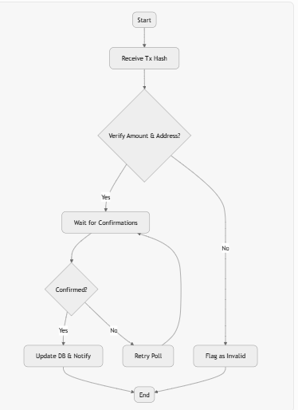

Use Case 05:
Field | Description
Actors | Merchant
Preconditions | Merchant is logged in.
Postconditions | Filtered transaction data displayed.
Flow of Events | 1. Merchant accesses dashboard and applies filters (date, status, currency). 2. System queries MongoDB for matching transactions. 3. System renders table, charts, and export options (CSV).
Alternative Flows | No filters—show all recent transactions.
Exceptions | No data—display empty state message.
Mapped to Functional Requirement | FR005

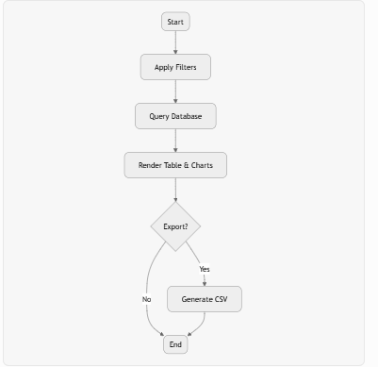

Use Case 06:
Field | Description
Actors | Merchant
Preconditions | Transaction is confirmed; Merchant logged in.
Postconditions | Refund processed and tracked.
Flow of Events | 1. Merchant selects Transaction ID and enters Refund Amount and Reason. 2. For ETH/SOL: System invokes smart contract to transfer funds. 3. For BTC: System generates manual transfer instructions. 4. System broadcasts refund transaction. 5. System updates logs and notifies Customer if email provided.
Alternative Flows | Full refund—auto-populate amount.
Exceptions | Insufficient funds in wallet—error and alert Administrator.
Mapped to Functional Requirement | FR006
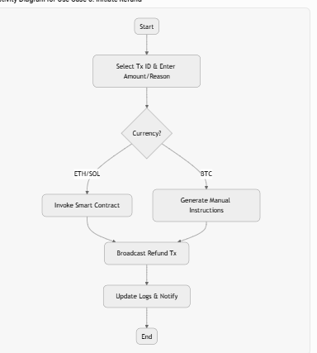

- References
[1] BTCPay Server Documentation, "BTCPay Server: Self-hosted Bitcoin payment processor," [Online]. Available: https://docs.btcpayserver.org/.
[2] CoinPayments, "CoinPayments API Reference," [Online]. Available: https://www.coinpayments.net/apidoc.
[3] A. Narayanan, J. Bonneau, E. Felten, A. Miller, and S. Goldfeder, Bitcoin and Cryptocurrency Technologies: A Comprehensive Introduction. Princeton, NJ, USA: Princeton Univ. Press, 2016.
[4] Ethereum Foundation, "Web3.js - Ethereum JavaScript API," [Online]. Available: https://web3js.readthedocs.io/.
[5] Solana Labs, "@solana/web3.js Documentation," [Online]. Available: https://docs.solana.com/developing/clients/javascript-api.
[6] CoinGecko, "CoinGecko API Documentation," [Online]. Available: https://www.coingecko.com/en/api/documentation.

